30th Sep 2011

Interest Rates & the Melbourne Property Market

Investors,

In this e-mail I am bringing together some information to put into perspective amidst the bad news headlines of doom and gloom.

It is a great opportunity now to review where you are at, what you are investing in and if you are getting the best deals you can suitable to your goals.

**Share Market**

It has been an interesting ride for investors recently with a lot of headlines and publicity surrounding the international stage centred on Europe and USA of sovereign debt issues, government bailouts and increasing government public debt which someone has to pay for at a point in time.

The share market has had a torrid time with severe volatility. Having a view of the ASX 200 and the DOW over a 5 year period and then a 6 month period shows the volatility within this market.

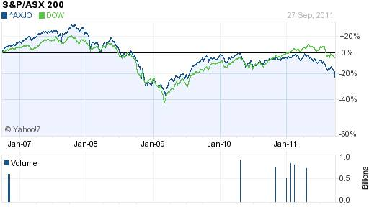

This is showing the ASX 200 has dropped > 20% over the 5 years.

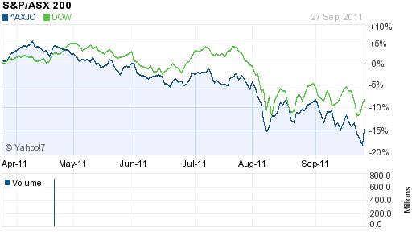

Even over the 6 month, the ASX 200 is down 15% with extraordinary volatility that does not seem to have an end point with the global uncertainty.

**Property Market**

There have been the ongoing bad news headlines about a potential major property crash in Australia, predicted back in 2007 to drop by 40% by one well publicised economist. There are many financial commentators (often following each other like sheep) who are convinced that the Australian property market is heading for a significant downturn. There is no doubt across the board that people are cautious and taking their time to buy. Melbourne auction clearance rates are generally below 60%, well below averages, the median price for Melbourne overall is down over the last 6 months, however over a 5 year period, Melbourne average has grown from $380k to $560k, or just under an average of 9% pa.

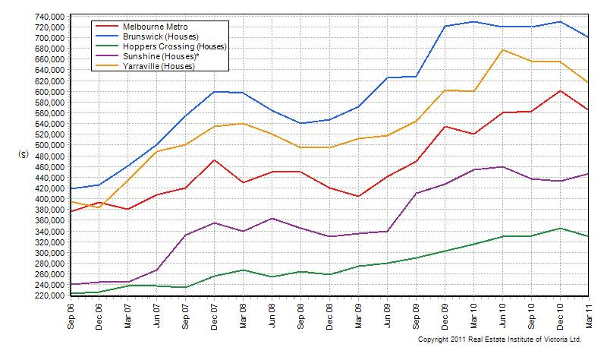

As you can see from a selected few suburbs, different areas of the market move at different times. Not all suburbs fall and as can be seen from the table below, there are still suburbs that continue to outperform the general market. It is a good time to buy for an investor but do the research first. We assist investors by providing property reports suitable for their needs.

#### Top 10 Growth Suburbs, Houses (Annual)

Note: Only suburbs where a minimum of 30 sales recorded in each quarter are included.

|  |  |  |  |  |
| --- | --- | --- | --- | --- |
|  | **Suburb** | **June-11 Median** | **June-10 Median** | **Annual Change (%)** |
| 1 | Prahran | $1,100,000 | $937,000 | 17.4 |
| 2 | Melton | $312,500 | $266,500 | 17.3 |
| 3 | Frankston South | $547,750 | $485,000 | 12.9 |
| 4 | Mount Martha | $677,000 | $604,000 | 12.1 |
| 5 | Sunbury | $375,000 | $337,250 | 11.2 |
| 6 | Berwick | $505,000 | $459,000 | 10.0 |
| 7 | Kilsyth | $456,000 | $421,000 | 8.3 |
| 8 | St Albans | $440,000 | $410,000 | 7.3 |
| 9 | Wyndham Vale | $315,000 | $297,500 | 5.9 |
| 10 | Surrey Hills | $1,126,000 | $1,065,000 | 5.7 |

Source – REIV

**Interest Rates**

There has been some intense competition within the major banks recently, where banks are vying for your business by offering greater discounts from standard variable interest rates, some offering to pay up to $1,000 in settlement fees and no application fees. They are also putting some very low interest rate fixed term deals, again to gain business but most likely their cost of longer term funds is cheaper now than it has been. Forget the Banks CEO’s rhetoric about dropping variable rates, they are just offering discounts instead. Lenders have priced for volume for some years now (greater the loan $, the better the interest rate discount) but they are starting to price for risk, so the lower the loan to value ratio (LVR), some lenders offer a low interest rate as well.  Conversely for higher LVR’s, often a higher interest rate and for low doc loans, almost always lower LVR’s available and slightly higher interest rates available.

For variable rates, normally > $250k loan size, best rates are 6.80% going to a competitive 6.85% to 7.00%. Any more than that and you are probably paying too much. Higher loan sizes may attract even keener discounts.

For fixed rates, again > $250k:

1 year best 5.99%, followed by a range from 6.34% to 6.54%

2 and 3 years fixed, best rate 6.24% then a range from 6.29% to 6.44%

5 year fixed are more expensive, 6.69% then followed by 6.84% to 6.90%.

Please check your current interest rates and give me a call or send an e-mail so I can compare for you to save you money.

**Our Service to You**

We provide a specialised service for investors wanting to create long term wealth for themselves and their families. We are finance strategists, credit advisers and mortgage brokers, helping you achieve your goals. Give us a call when you think its time to consider your options.

As well as providing a service to investors, we will assist you in purchasing as an owner-occupier, or upgrading to a new property, or simply looking at better pricing or structuring options for your current loans and banking or assisting seniors looking at possible reverse mortgage options.

Our business is built on referrals provided by clients, so please don’t keep us a secret, feel free to forward this e-mail to family and friends interested in their own financial future. Give us a call and book an appointment to see if it makes sense for you.

If you have any questions about any of these topics, give me a call.

*Helping People through Finance*